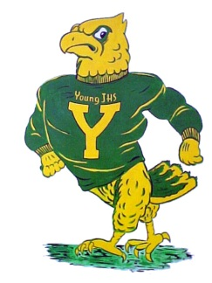 | Independent Work | Group Work | Teacher Communication
Be Ready | - Have your supplies  - Be on time  - Ask meaningful questions | - Assume positive intent  - Actively participate  - Brainstorm ideas | - Know what you want to ask  - Be clear about what you don’t understand  - Be patient
Be Respectful | - Do your very best work  - Appreciate the learning process  - Have a growth mindset!! | - Collaborate kindly  - Assume positive intent | - Be patient  - Be open to listening  - Accept responses if they are in disagreement with yours
Be Responsible | - Complete work on time  - Do your very best work | - Take ownership of your role  - Share and be open to ideas | - Voice meaningful questions/comments  - Be timely with your questions/comments  - Wisely use your teacher as a resource
U.S. History Expectations

